**Python Basic – 2[May 21st]**

Q.1. Create two int type variables, apply addition, subtraction, division and multiplications and store the results in variables. Then print the data in the following format by calling the variables:

First variable is __ & second variable is __.

Addition: __ + __ = __

Subtraction: __ - __ = __

Multiplication: __ * __ = __

Division: __ / __ = __

Answer: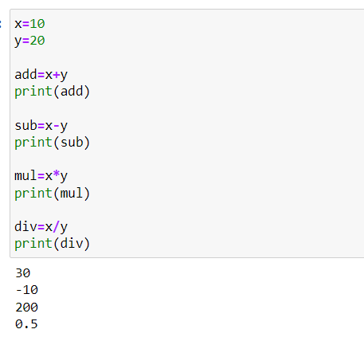

Q.2. What is the difference between the following operators:

(i) ‘/’ & ‘//’

(ii) ‘**’ & ‘^’

Answer: ‘/’ means division (float) divides the first operand by the second

‘//’ means division (floor) divides the first operand by the second

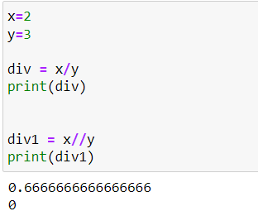

‘**’ means Power : returns first raised to power second x**y

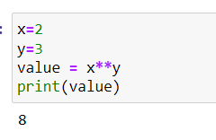

^ means Bitwise XOR operation [Bitwise operator acts on bit and perform the bit-by-bit operations]. These are used to operate on binary numbers

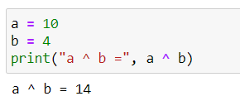

Q.3. List the logical operators.

Answer: Logical operators perform Logical AND, Logical OR, and Logical NOT operations. It is used to combine conditional statements.

|  |  |  |
| --- | --- | --- |
| Operator | Description | Syntax |
| and | Logical AND : True if both the operands are true | x and y |
| or | Logical OR: True if either of the operands is true | x or y |
| not | Logical NOT: true if the operand is false | not x |

Q.4. Explain right shift operator and left shift operator with examples.

Answer: **Bitwise right shift:** Shifts the bits of the number to the right and fills 0 on voids left( fills 1 in the case of a negative number) as a result. Similar effect as of dividing the number with some power of two.

a = 10 = 0000 1010 (Binary)

a >> 1 = 0000 0101 = 5

Example 2:

a = -10 = 1111 0110 (Binary)

a >> 1 = 1111 1011 = -5

**Bitwise left shift:** Shifts the bits of the number to the left and fills 0 on voids right as a result. Similar effect as of multiplying the number with some power of two.

Example 1:

a = 5 = 0000 0101 (Binary)

a << 1 = 0000 1010 = 10

a << 2 = 0001 0100 = 20

Example 2:

b = -10 = 1111 0110 (Binary)

b << 1 = 1110 1100 = -20

b << 2 = 1101 1000 = -40

Q.5. Create a list containing int type data of length 15. Then write a code to check if 10 is present in the list or not

Answer:

